**Practical No 9**

**Aim: Network Tracking using Sysinternals tools**

1. **Capture TCP/UDP packets (Tool: TcpView) :**

**To Do:** 1. Save to .txt file.

2. Whois

## Output:

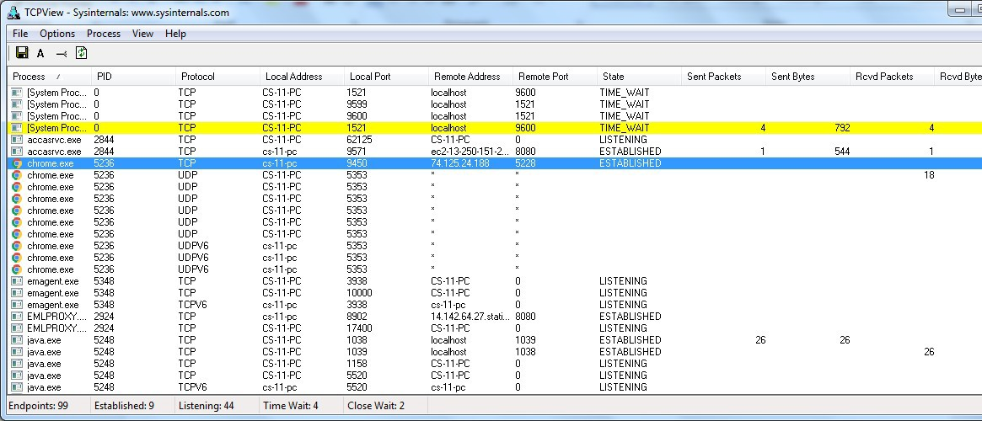

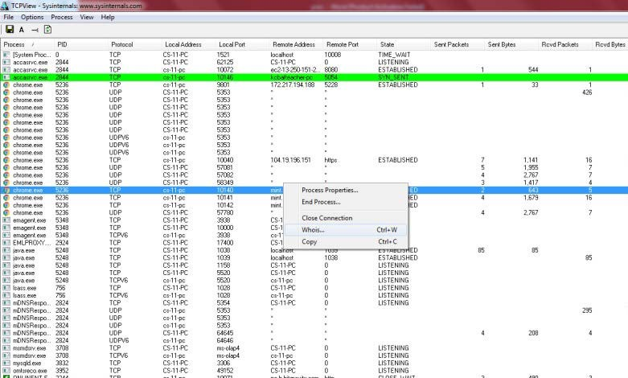

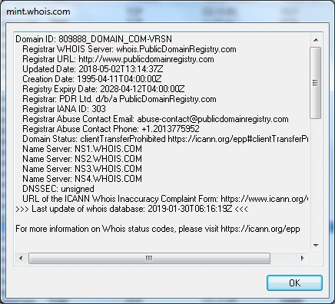

1. **Monitor Hard Disk (Tool: DiskMon) :**

**To Do:**

1. Save to .log file.
2. 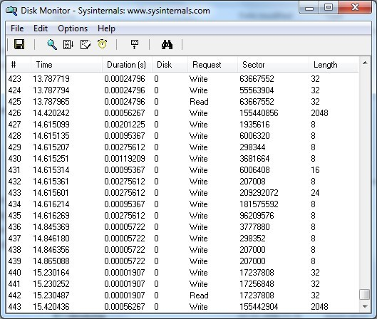Check operations performed in the disk as per time and sectors affected.

## Output :

1. **Monitor Virtual Memory ( Tool : VMMAP) :**

**To Do:**

1. Options – Show Free & Unusable Regions
2. File-> Select Process e.g. chrome.exe
3. Save to .mmp file.

## Output :

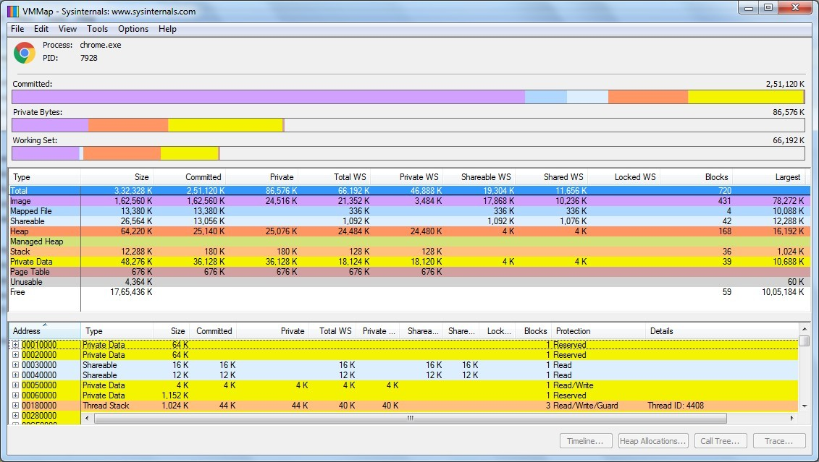

1. **Monitor Cache Memory (Tool: RAMMap)**

**TO DO :**

* 1. Save to .RMP file.

## Output:

